Welcome Back!

This year has been truly eventful for all of us here at Doris Dillon, but we have not halted in our commitment to making change even amidst the pandemic. We have so much to update you on, as so much has happened to improve the lives of the communities of Doris Dillon School. It is in times like these where we need to stand together to reach our communities of need. We are incredibly grateful for your continued support during these trying times for all.

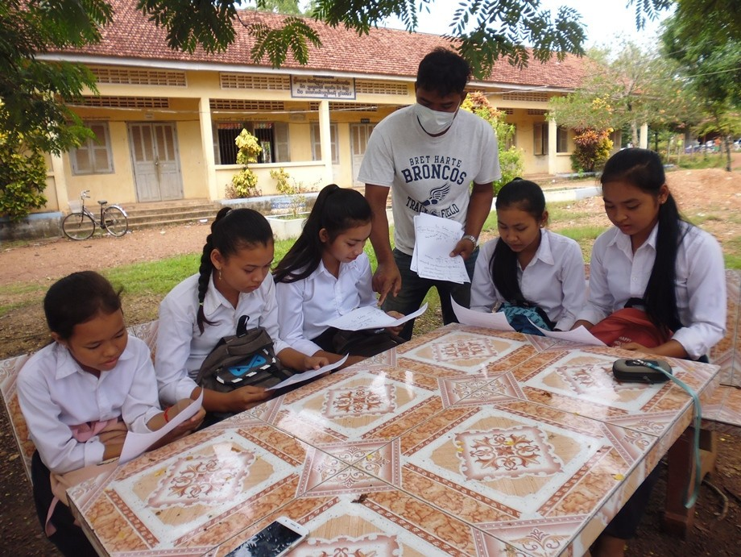

SaVeng, our computer and English teacher, engaging in an outdoor study group with students
Doris Dillon and COVID

In March, the Cambodian Education Ministry closed all schools. This meant all our students from the Doris Dillon School, scholarship girls from the two local high schools, and the twelve Leadership Academy students in Phnom Penh were sent home to wait out the virus.

Sokna Chhin, our in-country director, is keeping us apprised of any information the government releases. The 9th and 12th graders returned to school September 7. They will be reviewing for their national exams, which had to be postponed due to the virus.

Every 9th grader who wishes to go on to high school needs to pass this entrance exam. We have had great success preparing our students for this exam in past years. Many score in the top percentile, which is exciting for us and for their futures. Based on test results, we’ve been rated a top village school nationally for the last ten years. The testing is rigorous and held at an off campus site, similar to taking the SAT’s. However, the students must undergo testing in 8 different subjects: 2 hours in the morning, 2 in the afternoon, for 2 days.

Twelfth graders need to pass exit exams from their high schools before receiving their diplomas. Then, those who wish can take entrance exams for university. Our students who have qualified for university in the past have also had to pass an English literacy exam to be admitted. We currently have 6 students preparing for these two important exams. They have returned to Phnom Penh and have started reviewing for these exams at their local high school in the capital. Then they will be able to apply to their chosen universities. All six have indicated a preferred university & we know the staff at Leadership Academy will do everything in their power to be sure our students are ready for those tests.

We asked Sokna to tell all our scholarships students, at whatever educational level they are, that whenever the schools reopen, they can count on us to step up with tuition and room & board as needed, so they will feel confident that their hopes and dreams can still be realized.

Dr. Steven Kas, our board member who is Cambodian, communicates regularly with SaVeng.
SaVeng teaches English & computer education at Doris Dillon School as well as monitors our scholarship girls’ progress.

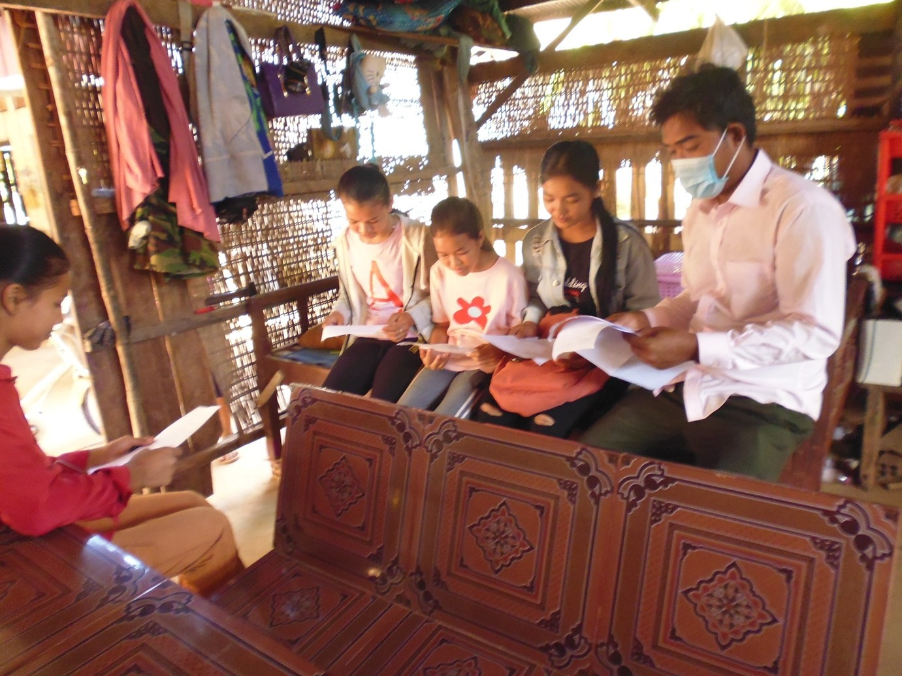

We are so fortunate to have Dr. Kas, who speaks Khmer and can converse with SaVeng (pictured above) in his native language, thereby giving us a fuller picture of what the local community is facing. Our principal, Mey Choeun, visits the students regularly at their homes to check on their well-being and to encourage them to continue reading. SaVeng also meets with students at the Doris Dillon School a couple of times a week to be sure they’re okay and to impress upon them the importance of continuing their education once school reopens. To do this, he drives by Moto two hours each way. These men are truly treasures to us and to their community. Our teachers also meet regularly with their classes to collect
homework and present them with new assignments. They are committed to helping their students through this emergency since they are living proof of what an education can provide.

We don’t think the virus has touched many in the Kep area. The remoteness of the school has worked to great advantage there.

Our gardener is still being paid to tend the garden, providing much needed vegetables to the school community. And our librarian works a few days each week to maintain the books, study the computer programs available, and prepare opportunities she can present to our students when they return. This respite has given her a real chance to work with the materials Lydia and Sofie Gmerek (board members) and West Valley College volunteers brought to the school last year.

FALL FUNDRAISER HAS BEEN POSTPONED TO 2021

Given the pandemic and now the crises caused by the western fires, we have chosen to cancel our fundraiser for this year. We know our doctors and nurses are our frontline warriors in the war against the COVID-19 virus, and they desperately need support to fund needed PPE. Additionally, so many here on the West Coast have lost homes and property to wildfires and could use donation. We are sorry not to see you all & share our students’ successes and future plans.

Those able to support our efforts can click on the following link to do so:

https://www.dorisdillonschoolincambodia.org/give

Or checks can be made out to: Doris Dillon School in Cambodia
Then, send it to: Doris Dillon School in Cambodia
1021 Mount Darwin Drive
San Jose, CA 95120
We are sorry not to see you all & share our students’ successes and future plans.
Doris Dillon School in Cambodia has qualified for matching grant status with Cisco. If you or anyone you know works for Cisco, please let them know that any donation made on behalf of the Doris Dillon School will be matched.

We also received an email from AmazonSmile that we received $84.74 this quarter from
smile.amazon.com. To date, AmazonSmile has donated $466.57 to Doris Dillon School in Cambodia. If you have not signed up for this program, it’s easy.

Google. : smile.Amazon.com

Click on “Get Started” which will ask you to sign into amazon.com. Then, click on
“supporting” which is found in small orange letters near the top of the page. You can enter Doris Dillon School in Cambodia. For every dollar you spend, the school receives half a cent. There is no extra cost to you; this makes the $84.74 we received pretty amazing!!! (There are third party vendors which do not participate in the program, but you are advised when you place your orders whether this is the case.)

Additionally, HCA, who owns many hospitals (Good Samaritan is one) matches any donation made by an employee up to $250. If you or someone you know works at a hospital owned by HCA, their donation could be doubled!

You can check with your employer to see if they having donation matching programs.

Thank you again for your kindness and generosity. Stay safe !!!

GARDEN NEWS

In the past year the garden at the Doris Dillon School has been expanded! Fruit trees like mango, papaya, and sapodilla have been planted. The garden also has pumpkins and other vegetables being grown as well. These fruits and vegetables are provided to the students for food and help to improve their nutrition and wellbeing. We continue to support the gardener’s salary for his hard work. If you would like to help us, you can send a check made out to: Doris Dillon School, putting a memo that you would like it to go to the garden. Thank you for supporting and going on this journey with us!

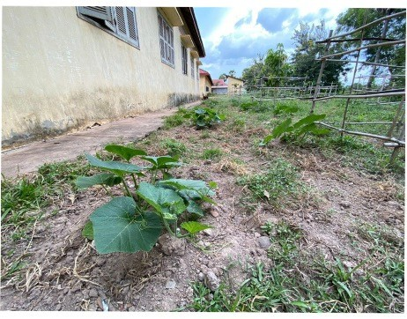
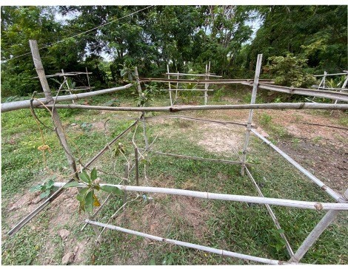
Pumpkin Plants Sapodilla Trees (Similar to Pear)
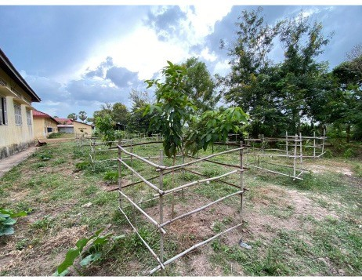
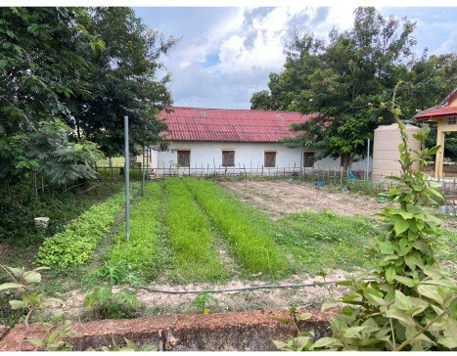
Mango Trees Our Garden

Our first ever grant proposal was just approved by the U. S. government!!!

After over a year’s work with the U.S. Embassy in Phnom Penh and many proposal revisions, we’ve been awarded a grant from the U. S. Department of State to administer the English Access Microscholarship Program. The program is a two- year English Intensive after-school program for 30 high school students from
villages around our school. They will also learn about principles of democracy and American history and culture and go on field trips to Kep and Phnom Penh. Learning English at a high level is essential for admission to respected universities in
Cambodia and abroad, which in turn provides access to a wide range of careers.

Here’s a link to more info on the program:

https://www.fhi360.org/projects/english-access-microscholarship-program-access

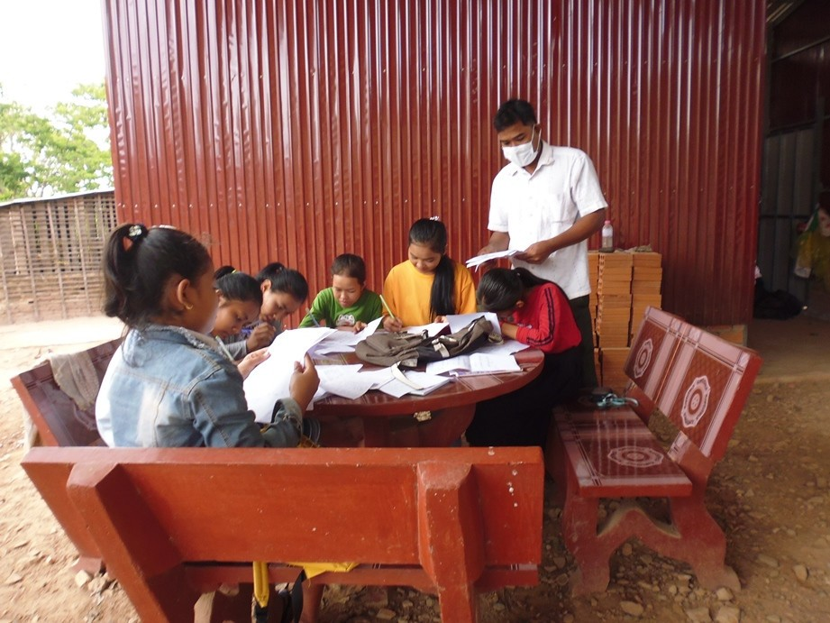

Educator Spotlight

For many years, through their non-profit La Pirogue d’Or, local villagers Ms. Myra Soth and her husband Savong Kao, have provided free breakfasts of sticky rice and tropical fruits rolled in banana leaves to village children. They also provide computer education at their home, using six computers. And, over the last 12 years, they have trained many girls in traditional Khmer dance. Perhaps most importantly, in 2007, they spearheaded efforts to build a reservoir near our school, which supplies water to over 4,000 villagers.

The photo above is of Chakriya Ka (one of our scholarship girls) and Ms. Myra Soth. The Chakriya’s family is so poor that the village often shares its meager food supply with them. Her parents do not own land, so they can't grow rice and must rely on day jobs the parents can secure to take care of their small family.

Through donations, we were able to help the family buy rice.

Myra Soth also teaches Cambodian classical dance to village girls. The last photos are of a recital she was preparing our village girls to present. Many of our students and families have benefited greatly from their free breakfast program, computer education, Khmer dance classes, and water from the reservoir.

We posted a video on our school’s Facebook page

(https://www.facebook.com/DorisDillonSchool/)

of a recent dance recital performed by many of our students that was held at Myra and Savong’s home. Please take a moment to view our students’ performance!

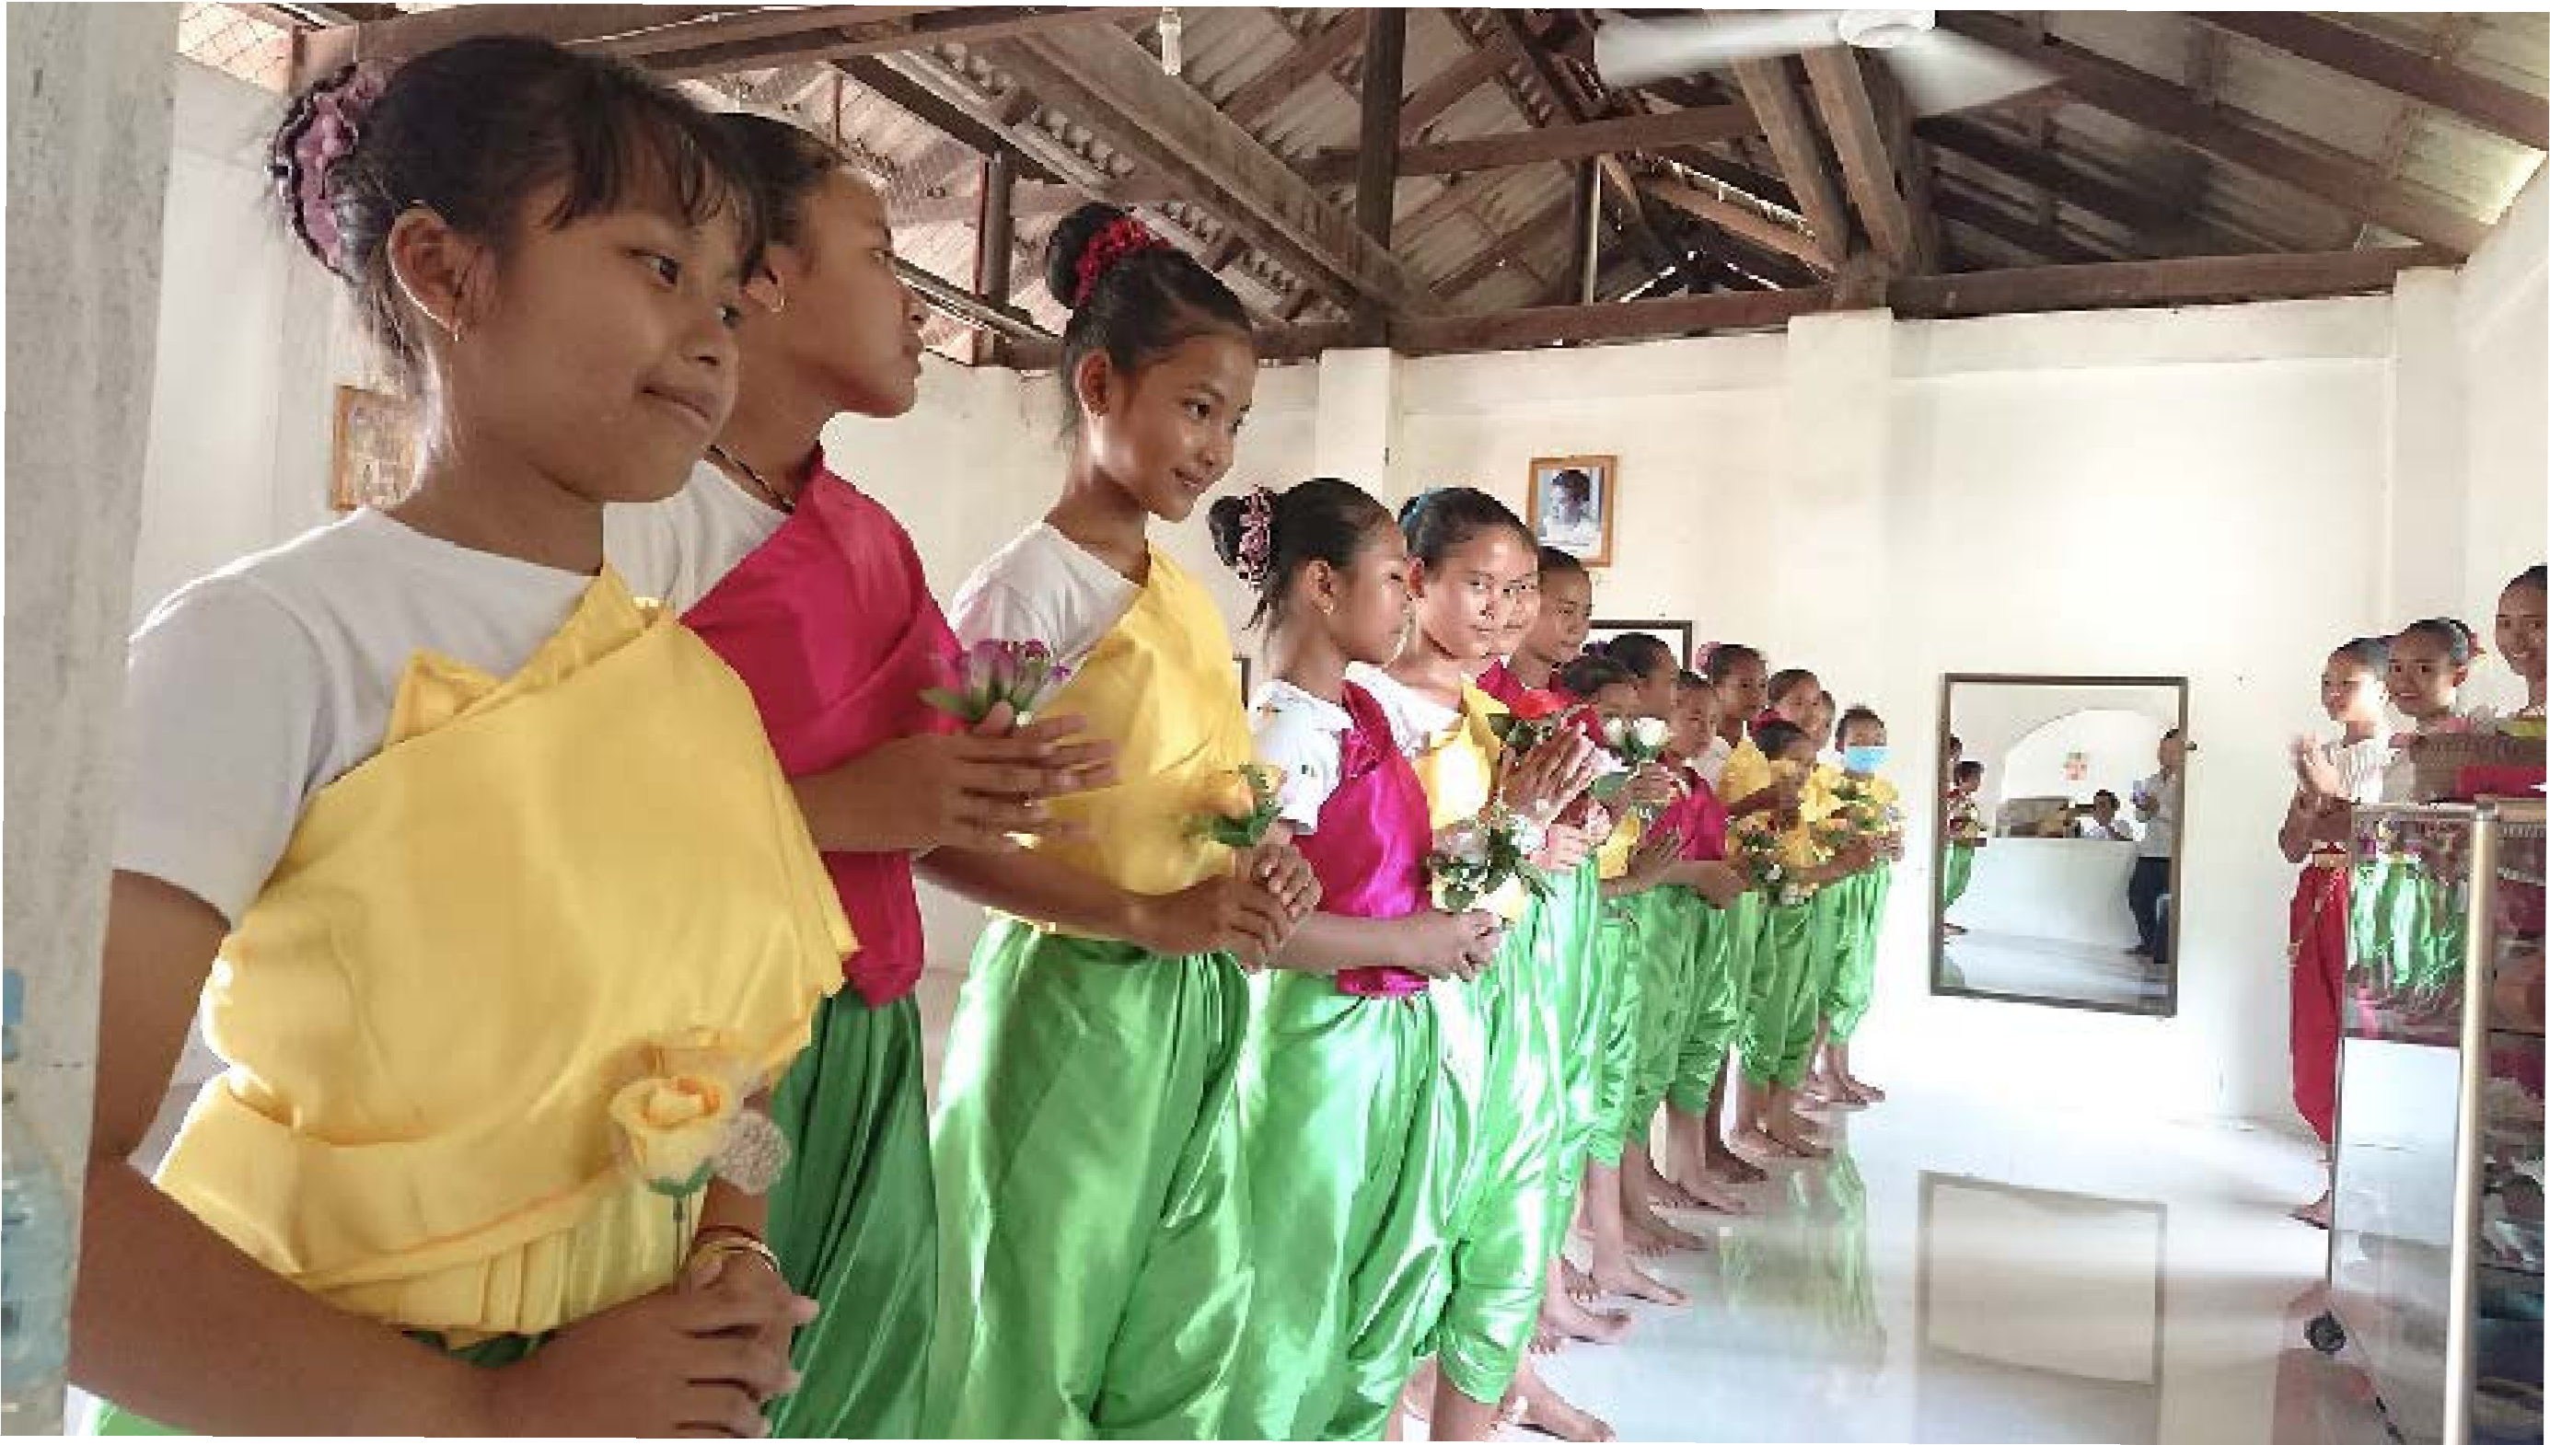

A Letter From Our Girl Scout Volunteers

Our names are Caroline and Allyson from Girl Scout Troop 61229 in San Jose, CA. Both of us were 8th graders when we started working on our Girl Scout Silver Award project to
support the students at the Doris Dillon School by creating a Girl Leadership Club (GLC). The Silver Award is the highest honor that middle school Girl Scouts can earn, requiring a minimum of 50 hours of volunteer work per girl to complete. Special thanks to Lydia Gmerek and Sokna Chhin for their guidance and help with our project for the DDS.

The GLC would be made up of 7th, 8th, and 9th grade girls who would meet during lunch periods. We understand that the DDS board is working to provide a lunch program for the GLC, and the students who would join the lunch period activities. The estimated cost of the lunches is about $1.50 per student.

We created a template for the GLC and gave autonomy for the girls involved to choose various activities. These activities include listening to and reading children’s books in English, reading English/Khmer bilingual books, learning about science from videos and hands on activities as well as suggested art, music, sports and other activities.

Together, we worked on making videos of how to put together the RAFT science kits that are at DDS, but had not been translated in Khmer. We downloaded our videos onto flash drives. Many US children’s books, such as the Magic Treehouse series and Island of the Blue Dolphins, had been donated to DDS. Therefore, we also downloaded the books being read in English from various free sites and put them onto flash drives so that students could practice reading and hearing spoken English. We know that being able to read, write and speak English is a requirement for higher education in Cambodia.

Due to the Covid 19 pandemic, the February trip to DDS was cancelled. We ended up mailing the flash drives, our GLC written suggestions, and our proposed GLC calendar via FedEx to Sokna in Phnom Penh. Sokna was kind enough to make sure they got to DDS, as FedEx wouldn’t go directly to the school. In addition, we used funds we raised by selling Girl Scout cookies to purchase shelves for the DDS library. (See pictures).

Like our middle school here, DDS closed during the pandemic. We hear that the school will reopen for students in January, and we hope the GLC club can start then. We understand the students love to read and learn.

Thank you so much to Caroline and Allyson! We truly appreciate your support and donation!!

SCHOLASTIC BOOKS supports Doris Dillon School Library

Doris Dillon, our school's inspiration, wrote many articles for Scholastic Magazine over
her years as an educator in San Jose, CA. She enjoyed a close relationship with the editorial staff at Scholastic. When they heard about our fledgling library at Doris Dillon School, they offered us a book donation. Then COVID hit! After many delays and reroutings, nearly 100 books arrived at our school and are being readied for our students in Cambodia. 9th graders will get their first crack at them on Sept. 7, when they return to school.

The beautiful bookcases you see were funded by San Jose Girls Scouts, Troop 61229
